Google Surveys Janae Hunt janae.hunt@canyonsdistrict.org

Log in/Account Set Up
- Begin by navigating to http://docs.google.com. You need a Google account, which you get when you apply for Gmail, Google Groups, Blogger.com or any other service run by Google. If you don't have a Google account yet, please create one (it's free), by clicking on the red button, labeled "Sign Up", then follow the instructions. Once you're set, return to http://docs.google.com. If you already have a Google account, sign in. You can also navigate to Google Docs* by clicking on “Documents” in the tool bar at the top of the Google Homepage.

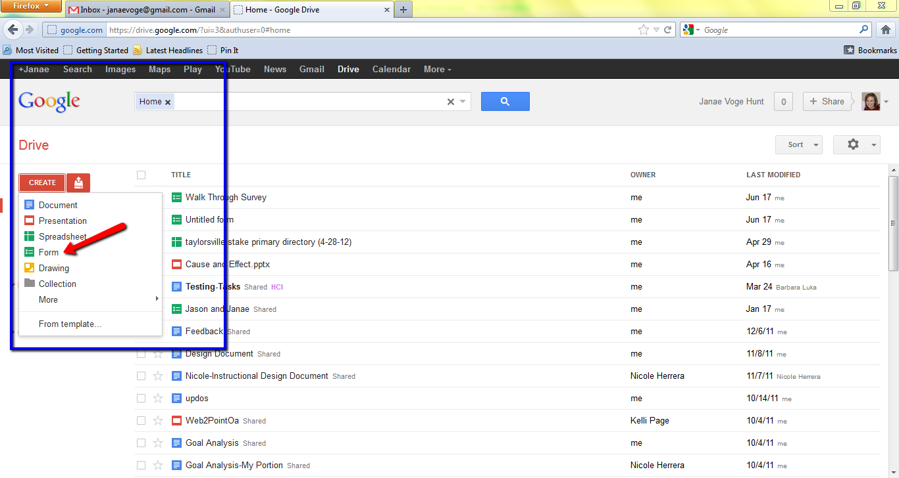
Creating a Survey
- Click on the red “Create” button on the left side of the screen. Select “Form” from the list of choices. A new window will appear. This is where you will create your survey.

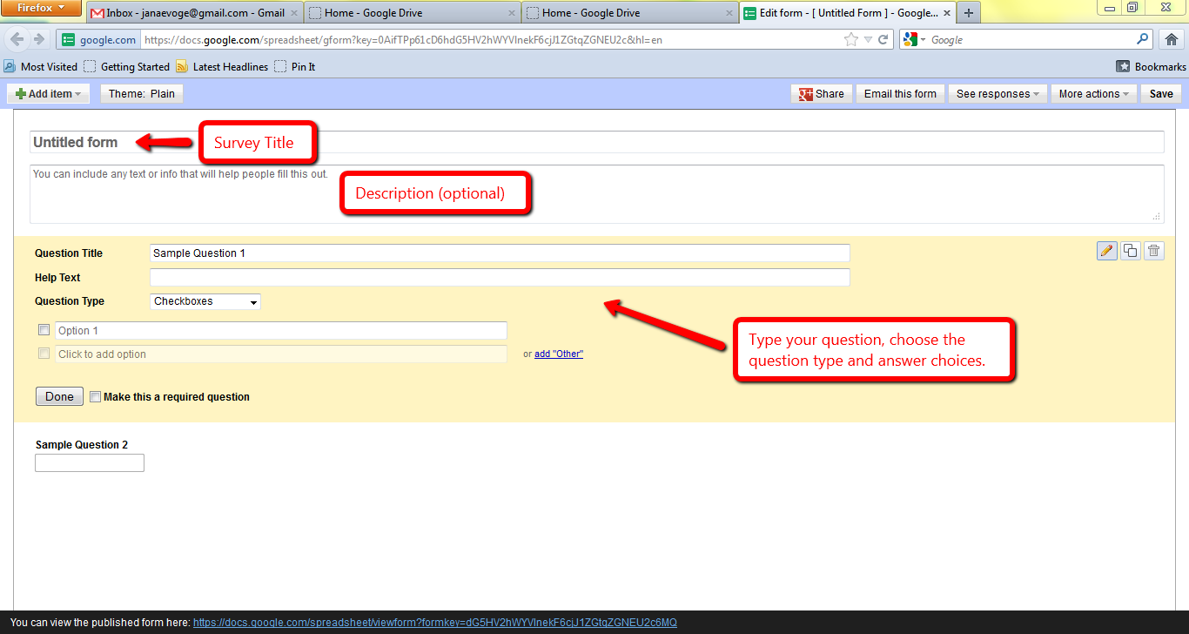
- The first line is the title of your survey. The second line is available for you to write a short description of the survey to help you remember what it is. This line is optional. There is also a place for you to put two sample questions. This section is also optional. If you do not want the samples to appear in your survey, hover over the question with your mouse. Click the trash can icon that appears in the top, right corner of the question.
- To add an item to your survey, click the “Add item” button in the top left corner or the tool bar. A list of choices will appear. You can choose to add a text, multiple choice, checkbox, list, scale or grid questions.
- After you have selected your item type a yellow section will appear on your screen. The first line is labeled “Question Title”. This is where you will type your first question. The second line “Help Text” is optional. The line “Question Type” allows you to change the type of question if you wish. In the section below “Question Type”, simply fill in your possible answer choices. When you are finished creating the question, click “Done”. Repeat this step to add more questions to your survey.
- To view your survey in its complete form, click the link that appears at the bottom of your survey.

Edit A Survey
- To edit a question, hover over the question with your mouse. Click the yellow pencil icon that appears in the top, right corner of the question.
- To delete a question, hover over the question with your mouse. Click the trash can icon that appears in the top, right corner of the question.
- To move a question to a different order, simply click and drag the question to where you would like it to appear.
- You may change the look of the survey by clicking “Theme” in the tool bar at the top of the page.

Accessing Your Survey and Data
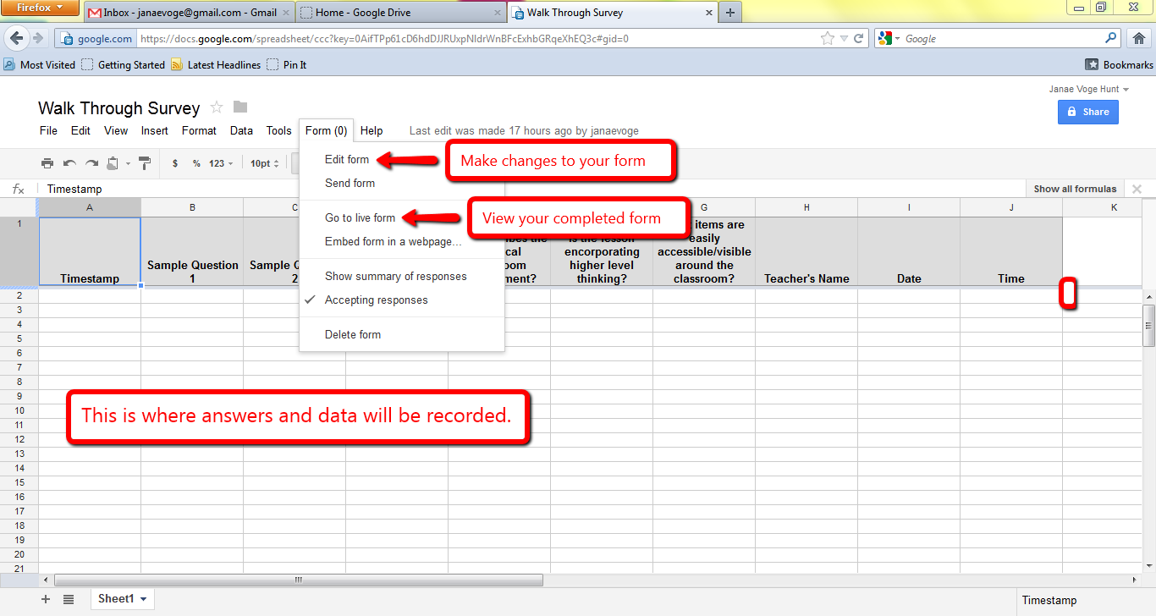
- You may access your survey results from your Google Docs homepage. When you click on your survey, it will appear as a spread sheet. This is where you will see the information you record.
- To access your survey in form view, while viewing your spreadsheet, click “Form” in the tool bar. Then, click “Go to live form”. It’s ready for you to use!
- To edit your survey, while view your spreadsheet, click “Form” in the tool bar. Then, click “Edit Form”.

*Google Docs will soon be found under the title “Google Drive”. You will still follow the same steps listed above, and the functionality of the documents you create will not change.

